APPLICATION TO WELLSTON CITY COUNCIL
-for the establishment of-
THE DOWNTOWN WELLSTON DESIGNATED OUTDOOR REFRESHMENT AREA
O.R.C. 4301.82

The Mayor respectfully submits the following application to the Wellston City Council to approve and enact the Downtown Wellston Designated Outdoor Refreshment Area, in accordance with O.R.C. 4301.82.

Mayor Anthony Brenner ________________________________

TABLE OF CONTENTS
- INTRODUCTION AND SUBMITTAL OF APPLICATION
- BOUNDARIES
- NATURE OF ESTABLISHMENTS
- QUALIFYING PERMIT HOLDERS
- LAND USE & ZONING
- PUBLIC HEALTH AND SAFETY

- INTRODUCTION AND SUBMITTAL OF APPLICATION
Section 4301.82 of the Ohio Revised Code (ORC) authorizes, effective April 30, 2017, municipalities under 35,000 in population to create a Designated Outdoor Refreshment Area or “DORA.” In order to consider creation of a DORA, the Executive Officer of the City of Wellston must file an application with the Wellston City Council (City Council), which meets certain statutory requirements. The application filing must be advertised for two consecutive weeks in a newspaper of general circulation. Not earlier than 30 days, but not later than 60 days, after the initial publication of the notice, the City Council may approved or disapprove of the application by ordinance or resolution.

The OHillCo Society expressed general support for the concept and a desire for this application to be prepared as the next step in considering enactment of a DORA.

In summary, this application would provide the following:

- The DORA would ease or make more accessible outdoor dining in front of liquor permit holding establishments. It would allow such establishments to serve alcoholic beverages in a plastic cup pursuant to the law within a designated area during certain hours. Creation of the DORA would relieve these establishments of current requirements for fencing around a dining area. Signage, sanitation, and safety requirements would be established by permits issued by the City.
- The Wellston DORA would provide the ability for individuals to walk within the DORA boundaries with an alcoholic beverage purchased from a liquor permit holding establishment during permitted hours. This authority would be limited, initially, to the hours of 11 a.m. to 11 p.m. Monday through Saturday.

- BOUNDARIES
In accordance with O.R.C. 4301.82(B)(1)(b), the boundaries of the DORA are depicted on the following map and described as follows. A list of the street addresses within the DORA are also attached.

Designated Outdoor Refreshment Area (DORA)
The proposed boundary is outlined in solid red lines and encompasses an area of 40.726 acres. The proposed boundary is defined as follows:

DORA Legal Description:
Commencing at the alleyway in the Northwest corner of the parcel occupied by Parcel M240110000100 (LeElla of Wellston);

Thence, South along said alleyway to the juncture with West Broadway;

Thence, commencing Westerly along West Broadway Street to the intersection with Michigan Avenue at the Northwest corner of the Parcel occupied by 120 West Broadway;

Thence, South crossing East 2nd Street to the Southwest corner of the parcel occupied by 244 South Michigan Avenue;

Thence, Easterly behind parcels occupied by M240210000102 (Fruth Pharmacy), M240210000100 (Piggly Wiggly), M240210000101 (Wellston Fire Department Training Academy), and the entirety of the parcel identified by M240220012500 (owned by City of Wellston);

Thence, commencing to the Southern property line occupied by 219 Ohio Avenue;

Thence, commencing at the junction of East 3rd Street and continuing Easterly to the Southeast corner of the parcel occupied by 229 Pennsylvania Avenue;

Thence, Northward to the intersection of East A St at the Northeast corner of the parcel occupied by 21 North Pennsylvania Avenue;

Thence, Westerly along East A Street to the point of termination at the public alleyway located in the Northwest corner of the parcel Identified as M240110000100 (LeElla of Wellston)

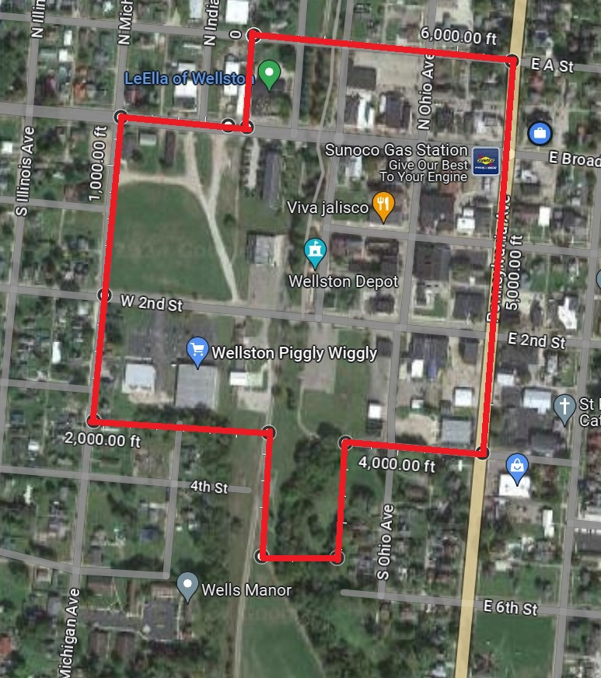

---- DORA BOUNDARY
DESIGNATED OUTDOOR REFRESHMENT AREA (DORA)

______ DORA BOUNDARY
DESIGNATED OUTDOOR REFRESHMENT AREA
(DORA)

STREET ADDRESSES IN THE DORA
Street Name | Range | Even/Odd
North park | 15 | Odd
Broadway & Railroad | 0
East Broadway | 1, 11, 13, 17, 23, 8, 10, 16, 104, 19, 16 | Even and Odd
North Pennsylvania | 5, 15, 21 | Odd
East E | 0
North Ohio | 22, 16, 0, 20, 16 | Even
A Street | 0
South Ohio | 7, 2, 105, 122, 120, 118, 0, 112, 23, 17, 15, 11, 24, 0, 10, | Even and Odd
South Pennsylvania | 7, 11, 23, 103, 107, 111, 113, 115, 223, | Odd
2nd Street & Pennsylvania Avenue | 121 | Odd
2nd Street | 138, 0, 134, 132, 126, 124, 122, 24112, 112, 0, 32, 122 | Even
East 2nd | 12, 32, 111 | Even and Odd
Railroad | 0, 111, 108 | Even and Odd
West 2nd | 110, 116, 0, 101, 9 | Even and Odd
South Michigan | 244, 238, 0, 1444 | Even
2nd Street & Michigan Avenue | 0
Ohio Avenue | 0, 219, 211, 117, 113, 107, 103, 110, 102 | Even and Odd
Pennsylvania Avenue | 219, 0, 229, 113, 111, 107 | Odd
West Broadway | 120, 118, 108, 0, 4 | Even
South Michigan & Broadway | 0
3rd Street | 0
Pennsylvania Avenue | 229,0, 219, 115, 19 | Odd
1st Street | 0, 11 | Odd
South Railroad | 110 | Even
2nd Street | 0
Ohio Avenue & 2nd Street | 0
East 1st Street | 108 | Even
Broadway | 10, 7, 101 | Even and Odd

- NATURE OF ESTABLISHMENTS
In accordance with O.R.C. 4301.82(B)(2), the nature and types of establishments that will be located within the DORA are listed below. The types of establishments located within the DORA are primarily businesses in the retail, dining, or services sectors. Examples include:
Business Name | Business Category | House Number | Street Direction | Street Name | Street Type
Gilliland Law Office | Legal Services | 23 | E | Broadway
CWC Barbershop |  | 23 | E | Broadway
VFW Post 9092 | Drink | 19 | E | Broadway
VFW Post 9092 | Drink | 17 | E | Broadway
JLorraine Beauty | Beauty | 15 | E | Broadway
US Post Office | Post Office | 101 | E | Broadway
Art of CareGiving | Medical/Training | 13 | E | Broadway
Broadway & Co. | Beauty | 11 | E | Ohio | Ave
Wellston City School Administration Office | Office | 1 | E | Broadway
Holzapfel Family Clinic | Medical | 22 | N | Ohio | Ave
Lori Silcott Ousley, Attorney at Law | Legal Services | 20 | N | Ohio | Ave
Pizza Pub | Restaurant/Drink | 1 | W | Broadway
Wellston City Board of Education | Parking lot | 7 |  | Broadway
LeElla Lanes | Entertainment/Drinks | 15 | N | Park | Ave
Honeysuckle Salon | Beauty | 2 | E | Broadway
Rusted Barn | Furniture | 8 | E | Broadway
Christina’s Closet | Boutique | 4 | E | Broadway
Previous Oths, Heiser, Miller, Waigland & Clagg LLC | Previous Legal Services, now owned by Landmark Properties, LLC | 16 | E | Broadway
Lockard Insurance LLC | Insurance | 1 | S | Ohio | Ave
KO Salon | Beauty | 5 | S | Ohio | Ave
Callebs, LLC | Sporting Goods | 125 | E | First | St
Lash Loft | Beauty | 1 | S | Ohio | Ave
Alley Cats Attic | Clothing | 13 | S | Ohio | Ave
T&C Custom Apparel | Clothing | 15 | S | Ohio | Ave
Vacant | Vacant | 17 | S | Ohio | Ave
ERA | Real Estate | 10 | S | Ohio | Ave
Vacant | Vacant | 14 | S | Ohio | Ave
Vacant | Vacant | 16 | S | Ohio | Ave
Retro Rocket | Hobby | 18 | S | Ohio | Ave
Darling Creations | Hobby | 20 | S | Ohio | Ave
Grace Clinic | Medical | 24 | S | Ohio | Ave
Mane Attraction | Beauty | 24 | S | Ohio | Ave
Unknown | Unknown | 19 | S | Ohio | Ave
Viva Jalisco | Restaurant/Drinks | 23 | S | Ohio | Ave
Louvee | City-owned/vacant | 101 | S | Ohio | Ave
Tangles | Beauty | 105 | S | Ohio | Ave
Chic-N-Sassy | Clothing | 107 | S | Ohio | Ave
Penn Station Appliances | Appliance | 109 | S | Ohio | Ave
Ohio Valley Bank | Finance | 123 | S | Ohio | Ave
Vacant | Vacant | 102 | S | Ohio | Ave
Vacant | Vacant | 110 | S | Ohio | Ave
Pet Pantry | Pet | 112 | S | Ohio | Ave
Patio Grubs and Suds | Restaurant/Drinks | 114 | S | Ohio | Ave
Fruth | Pharmacy | 120 | W | Second | St
Piggly Wiggly | Grocery | 116 | W | Second | St
Wellston Fire Department | First Responder/Class Rooms | 110 | W | Second | St
Jackson County EMS | First Responder | 110 | W | Second | St
The Depot | Park/City-owned | 111 |  | Railroad | Ave
Vacant | Vacant | 0 | E | Second | St
Vacant | Vacant | 9 | W | Second | St
Independent Transmission and Auto | Auto | 32 | E | Second | St
Jenkins Funeral Chapel | Funeral | 110 | E | Second | St
Vacant | Vacant | 116 | S | Ohio | Ave
Vacant | Vacant | 122 | E | Second | St
Vacant | Vacant | 124 | E | Second | St
Vacant | Vacant | 138 | E | Second | St
Wellston Public Library | Library | 121 | E | Second | St
McWilliams Funeral Home | Funeral | 125 | E | First | St
Flowerland | Floral | 24 | S | Ohio | Ave
Shops on First | Beauty, Clothing, Coffee, Fitness | 108 | E | First | St
Scotty’s on First | Restaurant/Drink | 10 | E | First | St
The Store | Gas Station/Convenience | 7 | S | Pennsylvania | Ave
BP | Gas Station/Convenience | 5 | N | Pennsylvania | Ave

- Qualifying Permit Holders
In accordance with O.R.C. 4301.82(B)(3), the DORA will encompass not fewer than four qualified permit holders.
Wellston has identified 6 qualified permit holders that will likely be included in the DORA:
Establishment Name | Permit Name | Address | Permit Type | Permit Number
Pizza Pub | Honeysuckle Lanes Corp | 1 W Broadway | D5 | 3958764
LeElla Lanes of Wellston LLC | LeElla Lanes of Wellston LLC | 15 N Park Ave | D1, D2, D3, D3A | 5096385
Viva Jalisco | Los Amigos of Wellston INC | 23 S Ohio Ave | D5 | 5295537
Patio Grubs & Suds LLC | Patio Grubs & Subs LLC | 114 S Ohio Ave | D1, D2, D3 | 6742319
Scotty’s on 1st LLC | Scotty’s on 1st LLC | 8, 10, 12 East 1st Street | D5, D6 | 7932315
VFW Post 9092 Wellston | VFW Post 9092 Wellston | 19 East Broadway | D4 | 9262355 90921

- LAND USE & ZONING
In accordance with O.R.C. 4301.82(B)(4), the uses of land within the current and future DORA are zoned DE (Downtown Enterprise), CB (Community Business), I (Industrial), and AR (Apartment Residential), and are in accord with Wellston’s master zoning plan:
Zoning Code Property Type
SR SUBURBAN RESIDENTIAL DISTRICT
UR URBAN RESIDENTIAL DISTRICT
MH-R MANUFACTURED HOME RESIDENTIAL DISTRICT
AR APARTMENT RESIDENTIAL DISTRICT
NB NEIGHBORHOOD BUSINESS DISTRICT
CB COMMUNITY BUSINESS DISTRICT
DE DOWNTOWN ENTERPRISE DISTRICT
I INDUSTRIAL DISTRICT
SU SPECIAL USE DISTRICT
RC REGIONAL COMMERCE DISTRICT

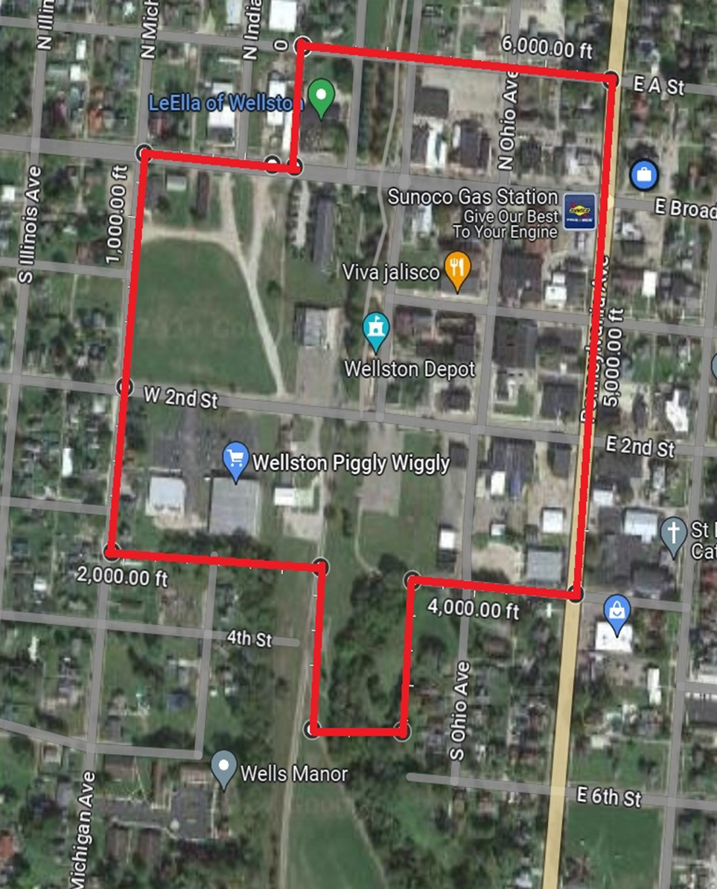

- PUBLIC HEALTH & SAFETY
In accordance with O.R.C. 4301.82(B)(S), the proposed requirements for the purpose of ensuring public health and safety within the DORA shall include:
Outdoor Dining Right of Way
Qualifying permit holders that desire to sell alcoholic beverages as part of providing an outdoor dining area in the City of Wellston’s right-of-way (adjacent to the establishment), must obtain a right-of-way permit and meet the requirements of the Codified Ordinances for right-of-way use, and the DORA. These policies will require the qualifying permit holder to submit a sanitation plan, and the physical layout of the tables, chairs, and other facilities to, among other things, comply with ADA requirements. It is anticipated that the busing of tables will be required and/or adequate trash cans be in place. Additionally, the permit review will ensure that there are adequate pedestrian passageways and that ingress/egress for emergency services is adequate. Failure to comply with the requirements of the permit can result in revocation.
Special Events
The City of Wellston requires that each special event using City property receive a permit from the City. Permit requirements may differ between events depending on their size, layout, use of right-of-way, and program. However, each event will be established. The necessity for portable bathrooms, handicap accessibility, pedestrian mobility, police, fire and emergency medical ingress and egress, crowd control, DORA boundary and trash management (cans, pick-up, etc.) will be addressed. Event organizers may be required to pay for special duty officers or overtime for public service or safety workers if necessary to ensure adequate health, public and safety requirements.
City of Wellston DORA Safety Plan
The Safety Plan will help maintain Public safety within the DORA and designate the number of personnel needed to execute the Safety Plan. This will be accomplished in the following manner:
Current Public Safety Personnel and adequate to maintain public safety within the DORA district. The City of Wellston Police Department (WPD) currently has multiple overlapping shifts which will enable it to maintain public safety within the DORA district.
WPD has flexibility when deploying resources and has years of experience dealing with all of the downtown events such as OHillCo Festival and other individual events which draw large crowds throughout the year.
Staffing for the DORA would consist of:
- Utilizes the current scheduled overlapping shift of 5a-3p, 7a-5p, 9a-7p and 9p-7a and gives the ability to actively patrol the DORA and have a visible presence in the assigned area.
- During the pre-planned or known special events that will increase the activity in the DORA area with WPD will seek organizations involved with the events to help supplement the manning needed to effectively police the DORA area. WPD will seek payment from such organizations for extra duty officer(s) as needed. The officer(s) primary responsibility would be in the downtown are business district and main street district where the DORA is located.
- All supervisors or OIC’s (Officers in Charge) have the flexibility to call in additional manning or emergency situations or if large crowds start to get out of control. Beginning with the commencement if the DORA and continuing for a period of six (6) consecutive months, the Mayor of the City Wellston, The Chief of Police of the City of Wellston, and the DORA review committee shall meet quarterly to review the Safety Plan herein. The purpose of this meeting will be to determine whether updates, modifications or supplementation may be advised or required, and in said event, such changes shall be presented to Council for consideration and implementation.

The Mayor of the City of Wellston, the Chief of Police of the City of Wellston, and the DORA review committee shall meet and review the Safety Plan as needed for any special events within the DORA or as other circumstances may require or arise.

The Mayor of the City of Wellston, the Chief of Police of the City of Wellston, and the DORA review committee have determined that the Safety Plan described herein is sufficient to maintain public safety within the DORA. This Safety Plan can be executed with the existing personnel of the City of Wellston.

