REQUEST FOR SPECIAL EVENT POLICE OFFICER(S)
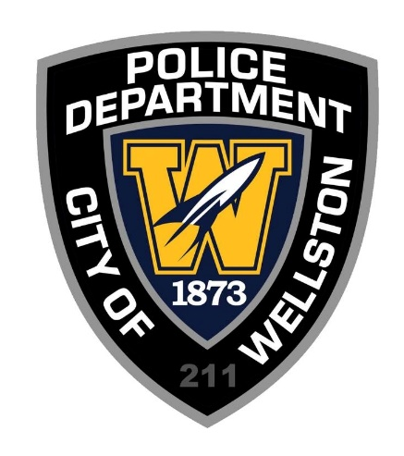

Any individual or organization that intends to hold a special event on City-Owned property or public right-of-way within the City’s corporation limit is required to submit an application to the Service Director at least 90 days prior to the scheduled event. Exceptions to this deadline must be approved by the City. Any public or private gatherings including races, block parties, festivals, parades, performances, or other group events that utilize public property or right-of-way will be subject to this policy and application process.

Specific Details:

- If a detail needs to be cancelled, the Wellston Police Department requires a one (1) hour prior notice.
- All or any police personnel requested for special event assignments will not be considered employees or agents of the requesting entity.
- The special duty assignment may be ended, or conditions imposed, at any time by the Chief of Police, or his designee. Additionally, the aforementioned has the authority to order any police officer to vacate or terminate any special duty assignment in response to emergency situations or whenever the assignment creates an unacceptable risk to health, safety, and welfare of the police officer and/or public.
- Parades will require 6-8 volunteers, obtained by the requesting organization, who will assist in traffic control.

REQUEST FOR SPECIAL EVENT POLICE OFFICER(S)

TOTAL OFFICERS REQUESTED: ____________

Type of Duty Requested: ( ) Traffic ( ) Security

Describe Event: ____________________________________________________________________________
____________________________________________________________________________________________________________________________________________________________________________________
Location of Event: ________________________________________________________________________
Date/Time: ________________________________________________________________________
Requesting Entity
Organization Name: ________________________________________________________________________
Address: ________________________________________________________________________
Phone: ____________________________ Email: _____________________________

Contact Person
Name: ____________________________ Phone: ______________________________
Email: ____________________________

I have read and agree to the conditions of this agreement with the Wellston Police Department, as attested to by my signature below.

Signature of Requesting Individual: ____________________________________ Date: ____________

FOR INTERNAL USE ONLY

Received by: ______________________________ Date/Time: ______________________________
Approved by: ______________________________ Date/Time: ______________________________
Officers Assigned: __________________________________________________________________________
Any Related Run/Incident #’s: ________________________________________________________________

